A PROJECT REPORT ON
INTELLIGENT ARCHITECTURE FOR DETECTING ADVANCED
PERSISTENT ATTACKS IN ENTERPRISE ENVIRONMENT
Submitted By
R.UMA SATYA SANTOSH 22JD1A05A0 SK.ABDUL HAFEEZ 22JD1A05A5
Y.PRASANTHI 22JD1A05C1
P.HARIKA 22JD1A0586

in partial fulfillment of the requirements for the award of the degree of

BACHELOR OF TECHNOLOGY
In

COMPUTER SCIENCE & ENGINEERING
Under the Esteemed guidance of Mrs.P.SPANDANA, B.Tech, M.Tech
(Assistant Professor)


DEPARTMENT OF COMPUTER SCIENCE & ENGINEERING ELURU COLLEGE OF ENGINEERING AND TECHNOLOGY

DUGGIRALA (V), PEDAVEGI (M), ELURU-534004 (AFFILIATED TO JNTUK, KAKINADA, ANDHRA PRADESH (INDIA))
2022-2026

DECLARATION

We hereby declare that the project entitled “INTELLIGENT ARCHITECTURE FOR DETECTING ADVANCED PERSISTENT ATTACKS IN ENTERPRISE ENVIRONME
NT” submit for the B. Tech (CSE) degree is our original work and the project has not formed the basis for the award of any other degree, diploma, fellowship or any other similar titles.

R.UMA SATYA SANTOSH (22JD1A05A0) SK.ABDUL HAFEEZ (22JD1A05A5)
Y.PRASANTHI (22JD1A05C1)

P.HARIKA (22JD1A0586)

Place : Date :

CERTIFICATE

This is to certify that the Project titled ―INTELLIGENT ARCHITECTURE FOR DETECTING ADVANCED PERSISTENT ATTACKS IN ENTERPRISE ENVIRONM
ENT‖ is the bonafide work carried out by R.UMA SATYA SANTOSH (22JD1A05 A0), SK.ABDUL HAFEEZ(22JD1A05A5), Y.PRASANTHI (22JD1A05C1),
P.HARIKA (22JD1A0586) students of B. Tech (CSE) of Eluru College of Engineering and Technology, affiliated to JNT University, Kakinada, AP (India) during the academic year 2025-26, in partial fulfillment of the requirements for the award of the degree of Bachelor of Technology (Computer Science and Engineering) and that the project has not formed the basis for the award previously of any other degree, diploma, fellowship or any other similar title.

Signature of the Guide Signature of the HOD
Mrs. P.SPANDANA, B.Tech, M.Tech Dr. S. SURESH, B.Tech, M.Tech, Ph.D
Assistant Professor Professor, HOD

EXTERNAL EXAMINER

VISION – MISSION - PEOs

Institute Vision | To Achieve Excellence in Engineering Education
Institute Mission | IM1: To deliver quality education through good infrastructure, facilities and committed staff.  IM2: To train students as proficient, competent and socially responsible engineers.  IM3: To promote research and development activities among faculty and students for betterment of the society.
Department Vision | Empower the students of computer science and engineering  department to be technologically strong, innovative and global citizens maintaining human values.
Department Mission | DM 1: Inspire students to become self-motivated and problem solving individuals.  DM 2: Furnish students for professional career with academic excellence and leadership skills.  DM 3: Create centre of excellence in Computer Science and Engineering.  DM 4: Empower the youth and rural communities with computer education.
Program Educational Objectives (PEOs) | Graduates of Computer Science & Engineering will:  PEO1: Excel in Professional career through knowledge in mathematics and engineering principles.  PEO2: Able to pursue higher education and research.  PEO3: Communicate effectively, recognize, and incorporate societal needs in their professional endeavors.  PEO4: Adapt to technological advancements by continuous learning.

PROGRAM OUTCOMES

1 | Engineering Knowledge: Apply the knowledge of mathematics, science, engineering fundamentals and an engineering specialization to the solution of complex engineering problems.
2 | Problem analysis: Identify, formulate, review research literature, and analyze complex engineering problems reaching substantiated conclusions using first principles of mathematics, natural sciences, and engineering sciences.
3 | Design/development of solutions: Design solutions for complex engineering problems and design system components or processes that meet the specified needs with appropriate consideration for the public health and safety, and the cultural, societal, and environmental considerations
4 | Conduct investigations of complex problems: Use research-based knowledge and research methods including design of experiments, analysis and interpretation of data, and synthesis of the information to provide valid conclusions.
5 | Modern tool usage: Create, select, and apply appropriate techniques, resources, and modern engineering and IT tools including prediction and modeling to complex engineering activities with an understanding of the limitations.
6 | The engineer and society: Apply reasoning informed by the contextual knowledge to assess societal, health, safety, legal and cultural issues and the consequent responsibilities relevant to the professional engineering practice.
7 | Environment and sustainability: Understand the impact of the professional engineering solutions in societal and environmental contexts, and demonstrate the knowledge of, and need for sustainable development.
8 | Ethics: Apply ethical principles and commit to professional ethics and responsibilities and norms of the engineering practice.
9 | Individual and team work: Function effectively as an individual, and as a member or leader in diverse teams, and in multidisciplinary settings.
10 | Communication: Communicate effectively on complex engineering activities with the engineering community and with society at large, such as, being able to comprehend and write effective reports and design documentation, make effective presentations, and give and receive clear instructions.
11 | Project management and finance: Demonstrate knowledge and understanding of the engineering and management principles and apply these to one‘s own work, as a member and leader in a team, to manage projects and in multidisciplinary environments.
12 | Life-long learning: Recognize the need for, and have the preparation and ability to engage in independent and life-long learning in the broadest context of technological change.
PROGRAM SPECIFIC OUTCOMES
PSO1: Have proficiency in algorithms, networking, s/w Engineering and Web Applications for systematic design of computer based system of varying complexity. PSO2: Qualifying national, international level competitive examinations for successful higher studies and employment.

PROJECT MAPPINGS

Batch No: | B - 11
Project Title | Intelligent Architecture For Detecting Advanced Persistent Attacks In Enterprise Environment.
Project Domain | Cyber Security
Type of the Project | Research-Based
Guide Name | P. Spandana, M. Tech
Student Roll No | Student Name
22JD1A05A0 | R. Uma Satya Santosh
22JD1A05A5 | SK. Abdul Hafeez
22JD1A05C1 | Y. Prasanthi
22JD1A0586 | P. Harika
COURSE OUTCOMES : At the end of the Course/Subject, the students will be able to

CO.No | Course Outcomes (COs) | POs | PSOs | Blooms Taxonomy& Level
R20C501.1 | Identify the real world problem with a set of requirements to design a solution. | 1,2,3,4,5,6,9,10,11,12 | 1,2 | Level-2: Applying
R20C501.2 | Implement, Test and Validate the solution against the requirements for a given problem. | 1,2,3,4,5,7,8,9,10,11,12 | 1,2 | Level-3: Analysing
R20C501.3 | Lead a team as a responsible member in developing software solutions for real world problems and societal issues with ethics. | 1,3,4,5,6,7,8,9,10,12 | 1,2 | Level-4: Analysing
R20C501.4 | Participate in discussions to bring technical and behavioral ideas for good solutions. | 1,2,3,4,5,6,7,8,9,10,11,  12 | 1,2 | Level-5: Evaluating
R20C501.5 | Express ideas with good  communication skills during presentations. | 1,5,6,7,8,9,10,12 | 1,2 | Level-1: Creating
R20C501.6 | Learn new technologies to contribute in the software industry for optimal solutions. | 1,2,3,4,5,7,8,9,10,11,12 | 1,2 | Level-6: Creating

Course Outcomes vs PO`s Mapping:

Courses Out Comes | P01 | P02 | P03 | P04 | P05 | P06 | P07 | P08 | P09 | P10 | P011 | P012
R20C501.1 | 3 | 3 | 3 | 2 | 3 | 3 | - | 3 | 3 | 3 | 3 | 3
R20C501.2 | 3 | 3 | 3 | 3 | 3 | - | 3 | 3 | 3 | 3 | 3 | 3
R20C501.3 | 2 | - | 3 | 3 | 3 | 3 | 3 | 3 | 3 | 3 | 3 | 3
R20C501.4 | 3 | 3 | 3 | 3 | 2 | 3 | 3 | 3 | 3 | 3 | 3 | 3
R20C501.5 | 3 | - | - | - | 3 | 3 | 3 | 3 | 3 | 3 | 3 | 3
R20C501.6 | 2 | 3 | 3 | 3 | 3 | - | 3 | 3 | 3 | 3 | 3 | 3
Total | 16 | 12 | 15 | 14 | 17 | 12 | 15 | 18 | 18 | 18 | 18 | 18
Average | 2.6 | 2 | 2.6 | 2.3 | 2.8 | 2 | 3 | 3 | 3 | 3 | 3 | 3

Justification of Mapping of Course Outcomes with Program Outcomes: POs mapped with CO.No:R20C501.1:
PO-1: Engineering Knowledge:
Applying the various concepts learned from engineering to gather requirements. PO-2: Problem Analysis:
Identify the formulae and obtaining the layout of the design using mathematical principles.

PO-3: Design/Development of solutions:
Identifying and Designing solutions for the problems related to health, cultural, society and environmental considerations.

PO-4: Conduct investigation of complex problems:
Researching various journals and published papers and knowing how to solve complex problems.

PO-5: Modern Tool Usage:
Selecting and Implementing the latest versions of the applications for modelling the complexity of the project.

PO-6: The Engineer and Society:
Implementing this knowledge to assess health and safety considerations.

PO-8: Ethics:
Implementing professional ethics and norms in engineering practices.

PO-9: Individual and Teamwork:
Individuals researched on the interested domain and concluded the requirements as a team.

PO-10: Communication:
Communication is needed to identify the problem and work as a team to define a solution.

PO-11: Project Management and Finance:
Implementing the engineering principles to work on complex problems.

PO-12: Life-long Learning:
Recognize the importance of technical knowledge in future studies

POs mapped with CO.No:R20C501.2:
PO-1: Engineering Knowledge:
Implementing the various concepts learned from engineering to gather requirements and design and test a solution.

PO-2: Problem Analysis:
Identify the formulae and obtaining the layout of the design and validate using mathematical principles.

PO-3: Design/Development of solutions:
Identifying and Designing solutions for the problems related to health, cultural, society and environmental considerations.

PO-4: Conduct investigation of complex problems:
Researching various journals and published papers and knowing how to solve complex problems.

PO-5: Modern Tool Usage:
Selecting and Implementing the latest versions of the applications for modelling the complexity of the project.

PO-7: Environment and Sustainability
Implementing this knowledge to assess its affects towards environment.

PO-8: Ethics:
Implementing professional ethics and norms in engineering practices.

PO-9: Individual and Teamwork:
Individuals researched on the interested domain and concluded the requirements as a team.

PO-10: Communication:
Communication is needed to Recognize the problem and work as a team to define a solution.

PO-11: Project Management and Finance:
Implementing the engineering principles to work on complex problems.

PO-12: Life-long Learning:
Recognize the importance of technical knowledge in future studies.

POs mapped with CO.No:R20C501.3:
PO-1: Engineering Knowledge:
Implementing the various concepts learned from engineering to gather requirement and work as a team to design and test a solution.

PO-3: Design/Development of solutions:
Recognizing and Designing solutions for the problems related to health, cultural, society and environmental considerations.

PO-4: Conduct investigation of complex problems:
Researching various journals and published papers and knowing how to solve complex problems.

PO-5: Modern Tool Usage:
Selecting and Implementing the latest versions of the applications for modelling the complexity of the project.

PO-6: The Engineer and Society:
Implementing this knowledge to assess health and safety considerations.

PO-7: Environment and Sustainability
Implementing this knowledge to assess its affects towards environment.

PO-8: Ethics:
Implementing professional ethics and norms in engineering practices.

PO-9: Individual and Teamwork:
Individuals researched on the interested domain and concluded the project as a team.

PO-10: Communication:
Communication is needed to Recognize the problem and work as a team to obtain a solution.

PO-12: Life-long Learning:
Recognize the importance of technical knowledge in future studies.

POs mapped with CO.No:R20C501.4:
PO-1: Engineering Knowledge:
Implementing the various concepts learned from engineering to gather requirement and work as a team to design and test a solution.

PO-2: Problem Analysis:
Recognize the formulae and obtaining the layout of the design and validate using mathematical principles.

PO-3: Design/Development of solutions:
Recognizing and Designing solutions for the problems related to health, cultural, society and environmental considerations.

PO-4: Conduct investigation of complex problems:
Researching various journals and published papers and knowing how to solve complex problems.

PO-5: Modern Tool Usage:
Selecting and Implementing the latest versions of the applications for modelling the complexity of the project.

PO-6: The Engineer and Society:
Implementing this knowledge to assess health and safety considerations.

PO-7: Environment and Sustainability
Implementing this knowledge to assess its affects towards environment.

PO-8: Ethics:
Implementing professional ethics and norms in engineering practices. PO-9: Individual and Teamwork:
Individuals researched on the interested domain and concluded the project as a team.

PO-10: Communication:
Communication is needed to recognize the problem and work as a team to obtain a solution.

PO-11: Project Management and Finance:
Implementing the engineering principles to work on complex problems.

PO-12: Life-long Learning:
Recognize the importance of technical knowledge in future studies.

POs mapped with CO.No:R20C501.5:
PO-1: Engineering Knowledge:
Implementing the various concepts learned from engineering to gather requirement and work as a team to design and test a solution.

PO-5: Modern Tool Usage:
Selecting and Implementing the latest versions of the applications for modelling the complexity of the project.

PO-6: The Engineer and Society:
Implementing this knowledge to assess health and safety considerations.

PO-7: Environment and Sustainability
Implementing this knowledge to assess its affects towards environment.

PO-8: Ethics:
Implementing professional ethics and norms in engineering practices.

PO-9: Individual and Teamwork:
Individuals researched on the interested domain and concluded the project as a team.

PO-10: Communication:
Communication is needed to recognize the problem and work as a team to obtain a solution.

PO-12: Life-long Learning:
Recognize the importance of technical knowledge in future studies.

POs mapped with CO.No:R20C501.6:
PO-1: Engineering Knowledge:
Implementing the various concepts learned from engineering to gather requirement and work as a team to design and test a solution.

PO-2: Problem Analysis:
Recognize the formulae and obtaining the layout of the design and validate using mathematical principles.

PO-3: Design/Development of solutions:
Identifying and Designing solutions for the problems related to health, cultural, society and environmental considerations.

PO-4: Conduct investigation of complex problems:
Researching various journals and published papers and knowing how to solve complex problems.

PO-5: Modern Tool Usage:
Selecting and Implementing the latest versions of the applications for modelling the complexity of the project.

PO-7: Environment and Sustainability
Implementing this knowledge to assess its affects towards environment.

PO-8: Ethics:
Implementing professional ethics and norms in engineering practices.

PO-9: Individual and Teamwork:
Individuals researched on the interested domain and concluded the project as a team.

PO-10: Communication:
Communication is needed to recognize the problem and work as a team to obtain a solution.

PO-11: Project Management and Finance:
Implementing the engineering principles to work on complex problems.

PO-12: Life-long Learning:
Recognize the importance of technical knowledge in future studies.
Course Outcomes vs PSOs Mapping:

Courses Out Comes | PSO1 | PSO2
R20C501.1 | 3 | 3
R20C501.2 | 3 | 3
R20C501.3 | 3 | 3
R20C501.4 | 3 | 3
R20C501.5 | 3 | 3
R20C501.6 | 3 | 3
Total | 18 | 18
Average | 3 | 3
Justification of Mapping of Course Outcomes with Program Specific Outcomes:

PSOs mapped with CO.No:R20C501.1:
PS0-1: Gaining knowledge in software engineering practices to gather requirements.
PSO-2: Able to use this knowledge in further studies.

PSOs mapped with CO.No:R20C501.2:
PS0-1: Gaining knowledge in software engineering practices like algorithms to design a solution.
PSO-2: Able to use this knowledge in further studies.

PSOs mapped with CO.No:R20C501.3:
PS0-1: Gaining knowledge in software engineering practices to gather requirements and networking for designing and communication.
PSO-2: Able to use this knowledge in further studies.

PSOs mapped with CO.No:R20C501.4:
PS0-1: Gaining knowledge in software engineering practices to gather requirements and bring in technical and behavioral ideas.
PSO-2: Able to use this knowledge in further studies.

PSOs mapped with CO.No:R20C501.5:
PS0-1: Gaining knowledge in software engineering practices to gather requirements and using good communication skills to express ideas.
PSO-2: Able to use this knowledge in further studies.

PSOs mapped with CO.No:R20C501.6:
PS0-1:Gaining knowledge in software engineering practices to learn to explore new technologies.
PSO-2: Able to use this knowledge in further studies.

Mapping  Level | Mapping Description
1 | Low Level Mapping with PO & PSO
2 | Moderate Mapping with PO & PSO
3 | High Level Mapping with PO & PSO

Member 1: R. Uma Satya Santosh (22JD1A05A0)
Member 2: SK. Abdul Hafeez (22JD1A05A5)
Member 3:Y.Prasanthi (22JD1A05C1)
Member 4 : P. Harika (22JD1A0586)

PROJECT GUIDE

ACKNOWLEDGEMENT
First, we would like to express our deepest appreciation to our advisor and guide, Mrs.P.SPANDANA, B.Tech, M.Tech for her sincere guidance, heartfull encouragement, and continuous support during our B. Tech project at Eluru College of Engineering and Technology. Her vision for insights into the problem resolution has greatly inspired us to put things in the right direction. It has been a great pleasure to conduct our project under her guidance.
We must also express our sincere thanks to our B.Tech Project Co-Ordinator and Assoc.Professor Mrs.K.V.JHASI RANI M.Tech, (Ph.D). The Head of the Department Dr.S.SURESH, B.Tech, M.Tech, Ph.D, and to all of the faculty members of the Computer Science and Engineering of Eluru College of Engineering and Technology for their endeavors in our academic education.
We would like to express our gratitude to Dr.P.BALA KRISHNA PRASAD, B.Tech, M.Tech, Ph.D Principal, and the Management of Eluru College of Engineering & Technology for motivating and providing us adequate facilities and continuous improvements and suggestion without which this project would not have seen the light of the day.

R.UMA SATYA SANTOSH (22JD1A05A0) SK.ABDUL HAFEEZ (22JD1A05A5)
Y.PRASANTHI (22JD1A05C1)

P.HARIKA (22JD1A0586)

ABSTRACT

Persistent cyber-attacks, particularly Advanced Persistent Threats (APTs), pose a significant risk to enterprise networks due to their stealthy nature, long dwell time, and ability to bypass traditional security mechanisms. Conventional intrusion detection systems often fail to identify such attacks in their early stages, leading to severe data breaches and operational disruptions. This paper proposes an AI-assisted end-to-end architecture designed to detect persistent attacks across enterprise environments in real time. The proposed system integrates machine learning and deep learning techniques with network traffic analysis, behavioral profiling, and anomaly detection to identify suspicious activities across multiple stages of an attack lifecycle. By leveraging automated data collection, feature extraction, and intelligent decision-making models, the architecture ensures improved detection accuracy and reduced false positives. Additionally, the system incorporates continuous learning capabilities to adapt to evolving threat patterns. Experimental results demonstrate that the proposed framework significantly enhances detection efficiency and provides a scalable, robust solution for modern enterprise cybersecurity challenges.

LIST OF FIGURES

Figure No. | Name of the Figure | Page No.
4.1 | System Architecture | 12
4.2.1 | Class Diagram | 13
4.2.2 | Use case Diagram | 14
4.2.3 | Sequence Diagram | 14
4.2.4 | Activity Diagram | 15
6.3 | Run Web Server | 36
7.1 | Home page | 37
7.2 | Registration page | 37
7.3 | Admin login page | 38
7.4 | Home page after Admin login | 38
7.5 | View Registered users | 39
7.6 | User login page | 39
7.7 | Home page after user login | 40
7.8 | Cyber Attack Detecting | 40
7.9 | Dataset Upload | 41
7.10 | Module -3 | 41
7.11 | Module-4 | 42
7.12 | Module-5 | 42

TABLE OF CONTENTS

S.NO TITLE PAGE NO

- INTRODUCTION 1
  - Motivation 2
  - Problem Definition 2
  - Objective of the Project 2
- LITERATURE SURVEY 3
- SYSTEM ANALYSIS 4
  - Existing System 4
    - Disadvantages of Existing System 4
  - Proposed System 4
    - Advantages of Proposed System 5
  - System Requirements 5
    - Hardware Requirements 5
    - Software Requirements 5
  - Functional Requirements 5
  - Non-Functional Requirements 6
    - Advantages 6
    - Disadvantages 6
    - Key Learning 7
  - System Study 7
    - Feasibility Study 7
    - Study of the System 8
  - Modules 11
- SYSTEM DESIGN 12
  - System Architecture 12
  - UML Representation 12
  - Input & Output Design 16
- SYSTEM IMPLEMENTATION 18
  - Source Code 18
  - Algorithms 24
  - Software Environment 27
- TESTING 31
  - Types of Testing 31
  - Test strategy and approach 33
- RESULTS 37
- CONCLUSION & FUTURE WORK 43
- REFERENCES 44

INTRODUCTION

In recent years, the rapid expansion of enterprise networks and the increasing reliance on digital infrastructure have made organizations more vulnerable to sophisticated cyber threats. Among these, persistent attacks—commonly referred to as Advanced Persistent Threats (APTs)—are particularly dangerous due to their targeted, stealthy, and multi-stage nature. These attacks typically infiltrate networks through vulnerabilities, establish a foothold, and remain undetected for extended periods while extracting sensitive information or disrupting operations. Traditional security solutions such as firewalls, signature-based intrusion detection systems, and rule-based monitoring tools are often inadequate in detecting such advanced threats, as they rely heavily on known attack patterns and lack adaptability.
To address these limitations, Artificial Intelligence (AI) has emerged as a powerful tool in cybersecurity, offering capabilities such as pattern recognition, anomaly detection, and predictive analytics. AI-driven systems can analyze large volumes of network data, identify hidden patterns, and detect deviations from normal behavior that may indicate malicious activity. However, many existing solutions focus on isolated components of threat detection rather than providing a comprehensive, end-to-end approach.
This paper introduces an AI-assisted end-to-end architecture for detecting persistent attacks in enterprise networks. The proposed framework integrates multiple components, including data acquisition, preprocessing, feature engineering, machine learning-based detection, and response mechanisms, into a unified system. By correlating data from various sources such as network traffic logs, user behavior, and system events, the architecture provides a holistic view of network security. Furthermore, the system is designed to continuously learn and adapt to new attack strategies, ensuring long-term effectiveness. The goal of this work is to enhance early detection, minimize response time, and improve overall resilience against persistent cyber threats in enterprise environments.

Motivation:
The increasing dependence on digital systems has led to a rise in sophisticated cyber threats such as Advanced Persistent Threats (APTs). Traditional security systems are not capable of detecting these attacks effectively due to their reliance on predefined rules. This creates a need for intelligent and adaptive security solutions. The project is motivated by the potential of Artificial Intelligence and Machine Learning to improve threat detection accuracy. By analyzing network behavior and identifying anomalies, the system can detect hidden attacks in real time. It also aims to reduce false positives and minimize manual effort. The ultimate goal is to enhance enterprise security and provide a scalable solution for modern cyber threats.

Problem Definition:
Enterprise networks are increasingly vulnerable to advanced cyber-attacks such as Advanced Persistent Threats (APTs), which are difficult to detect using traditional security systems. Existing solutions rely heavily on predefined signatures and rules, making them ineffective against unknown or evolving threats. These attacks often remain undetected for long periods, causing significant data breaches and financial losses. Additionally, the large volume of network data makes manual monitoring inefficient and error-prone. There is a lack of intelligent systems that can analyze multi- source data and detect multi-stage attacks in real time. To address these challenges, there is a need for an automated and adaptive solution using Artificial Intelligence and Machine Learning. The project aims to develop a system that can accurately identify and respond to persistent cyber threats.

Objective of the Project:
The main object of this project is to develop an intelligent and automated system to detect Advanced Persistent Threats (APTs) in enterprise networks. The system aims to improve the accuracy and speed of threat detection by using Artificial Intelligence and Machine Learning techniques. It focuses on analyzing network traffic, user behavior, and system data to identify hidden and multi-stage cyber-attacks. The project also aims to reduce false positives and enhance overall network security..
- To enable continuous monitoring of network behavior.
- To analyze large-scale network data efficiently.
- To provide faster response to potential security attacks.
- To strengthen overall network protection mechanisms.
- To support intelligent decision-making in threat detection.
- To enhance reliability of security systems.

LITERATURE SURVEY

- Title: AI-Based Intrusion Detection System for Network Security Authors: Sharma, P., & Verma, R. (2020)
Abstract: This study focuses on using machine learning algorithms to detect network intrusions. The system analyzes network traffic patterns and identifies malicious activities. Results show improved detection accuracy compared to traditional rule-based systems, but it struggles with detecting advanced persistent threats.
- Title: Machine Learning Techniques for Cyber Attack Detection Authors: Gupta, S., & Mehta, K. (2019)
Abstract: The authors explored various machine learning models such as SVM and KNN for identifying cyber-attacks. The models achieved better performance than conventional methods; however, they require proper feature selection and are less effective with large-scale data.
- Title: Deep Learning Approaches for Network Anomaly Detection Authors: Reddy, V., & Kumar, S. (2021)
Abstract: This research uses deep learning models like CNN and LSTM to detect anomalies in network traffic. The approach improves detection of complex attack patterns but requires high computational resources.
- Title: Anomaly Detection in Enterprise Networks Using Hybrid Models Authors: Khan, A., & Ali, M. (2022)
Abstract: The paper proposes a hybrid approach combining machine learning and statistical methods for anomaly detection. It improves accuracy and reduces false positives, but integration complexity remains a challenge.
- Title: AI-Driven Framework for Advanced Persistent Threat Detection Authors: Patel, R., & Singh, D. (2023)
Abstract: This study presents an AI-based framework for detecting APT attacks using behavioral analysis and anomaly detection. The system shows strong performance in identifying multi-stage attacks and highlights the importance of real-time monitoring.

SYSTEM ANALYSIS

EXISTING SYSTEM

The existing systems for detecting cyber-attacks in enterprise networks primarily rely on traditional security mechanisms such as firewalls, signature-based intrusion detection systems (IDS), intrusion prevention systems (IPS), and rule-based monitoring tools. These systems are designed to identify known threats by comparing incoming network traffic against predefined signatures or rules. While they are effective in detecting previously identified attacks, they struggle to recognize new, unknown, or evolving threats, especially persistent attacks like Advanced Persistent Threats (APTs). Additionally, many existing solutions operate in isolation, analyzing only specific parts of the network rather than providing a comprehensive, end-to-end view of security events.
    - DISADVANTAGES OF EXISTING SYSTEM

      - In ability to detect unknown or zero-day attacks, as most systems rely on predefined signatures and rules.
      - Lack of adaptability to evolving attack patterns and new cyber threats.
      - Difficulty in handling large-scale and high-dimensional network data in enterprise environments.

PROPOSED SYSTEM

The proposed system presents an AI-assisted architecture for detecting persistent attacks in enterprise networks. It integrates Machine Learning and Artificial Intelligence techniques for accurate threat detection. The system continuously monitors network traffic, user behavior, and system logs to identify anomalies. It collects data from multiple sources such as network packets and firewall logs. The data is preprocessed and relevant features are extracted to improve model performance. An AI-based detection engine is used to identify both known and unknown threats. The system applies anomaly detection and behavioral analysis for real-time monitoring. A correlation module combines data from different sources to detect multi-stage attacks. It generates alerts and supports automated response actions. The system also includes continuous learning to adapt to new and evolving cyber threats.

ADVANTAGES OF PROPOSED SYSTEM

- Effectively identifies multi-stage and persistent attacks such as Advanced Persistent Threats (APTs).
- Provides accurate detection of both known and unknown (zero-day) attacks using AI and machine learning techniques.
- Minimizes manual intervention by automating detection and response processes.
- Supports proactive threat detection, helping prevent attacks before significant damage occurs.

SYSTEM REQUIREMENTS

HARDWARE REQUIREMENTS
- RAM : 512MB
- Hard Disk : 40 GB

SOFTWARE REQUIREMENTS
- Operating system : Windows 7 or above
- Coding Language : Python
- Front End : HTML,CSS
- Frame Work : Django

FUNCTIONAL REQUIREMENTS

- Data Collection: The system should collect data from multiple sources such as network traffic, system logs, and user activities.
- Data Preprocessing: The system should preprocess and clean the collected data for further analysis.
- Feature Extraction: The system should extract relevant features from raw data to improve detection accuracy.
- Anomaly Detection: The system should detect anomalies in network behavior using AI/ML techniques.
- User Behavior Analysis: The system should analyze user behavior to identify suspicious patterns.
- Data Correlation: The system should correlate data from different sources to identify multi-stage attacks.

- System Monitoring: The system should allow administrators to monitor system activities and manage responses.

NON-FUNCTIONAL REQUIREMENTS
- Performance: The system should provide fast response time for threat detection and mitigation.
- Scalability: The system should be scalable to handle large volumes of enterprise network traffic.
- Usability: The system should have a user-friendly interface for administrators and security analysts.
- Data Security & Privacy: The system should ensure data security and privacy during processing and storage.
- Security: The system should be flexible to adapt to new and evolving cyber threats.
- Reliability: The system should be reliable and available with minimal downtime.
- Maintainability: The system should provide fast response time for threat detection and mitigation.

ADVANTAGES
- Detection of Advanced Attacks
- Real-Time Monitoring
- Reduced False Positives
- Detection of Unknown Attacks
- Multi-Source Data Analysis
- Automation of Security Tasks
- Scalable Architecture
- Continuous Learning
- Improved Security Posture
- Faster Incident Response

DISADVANTAGES
- High Initial Cost
- Complex Implementation
- Requirement of Large Datasets
- High Training Time
- Resource Intensive
- Risk of False Negatives
- Maintenance Effort
- Dependency on Data Quality
- Security Risks to AI Models
- Need for Skilled Professionals

KEY LEARNING
- Cybersecurity Concepts Understanding
- Application of AI in Security
- Data Collection and Preprocessing
- Machine Learning Algorithms Knowledge
- Anomaly Detection Techniques
- System Design Skills
- Multi-Source Data Integration
- Automation in Cybersecurity
- Model Evaluation and Optimization
- Practical Implementation Skills

SYSTEM STUDY

FEASIBILITY STUDY
The feasibility of the project is proposed system is technically feasible due to the availability of advanced Machine Learning frameworks and modern computing resources. It is economically viable as it helps reduce long-term losses caused by cyber-attacks while minimizing manual effort and operational costs. The system can be easily integrated with existing enterprise tools and supports scalable data processing. This is to:
      - ECONOMICAL FEASIBILITY
      - TECHNICAL FEASIBILITY
      - SOCIAL FEASIBILITY

ECONOMICAL FEASIBILITY
The proposed system is economically feasible as it provides significant long-term cost benefits despite the initial investment in infrastructure, data storage, and model development. By using Machine Learning and automation, the system reduces the need for manual monitoring and lowers operational costs. It helps prevent financial losses caused by cyber-attacks, data breaches, and system downtime. Additionally, the use of open-source tools and scalable technologies further minimizes implementation expenses, making the system cost-effective and sustainable for enterprise environments.

TECHNICAL FEASIBILITY
This proposed system is technically feasible due to the availability of advanced technologies such as Machine Learning and deep learning frameworks. Tools like Tensor Flow, PyTorch, and Scikit-learn support the development of efficient detection models. The system can handle large-scale data using modern computing resources such as cloud platforms and distributed processing. Integration of multiple data sources like network traffic, system logs, and user activity is achievable using existing enterprise tools. Additionally, the algorithms used for anomaly detection and behavior analysis are well- established, making the system reliable and practical to implement.

SOCIAL FEASIBILITY
The proposed system is socially feasible as it enhances the security and privacy of users by protecting sensitive data from cyber-attacks. It helps organizations build trust with customers by ensuring safe and reliable digital services. The system reduces the risk of data breaches, which can impact individuals and society. It also supports a secure digital environment, which is essential in today‘s technology-driven world. Additionally, the system is designed to be user-friendly, making it easy for security analysts and administrators to operate effectively.

STUDY OF THE SYSTEM
      - Numpy
      - Pandas
      - Matplotlib
      - Scikit-learn
      - Keras
      - Seaborn
      - Tensorflow

NumPy:
NumPy is a general-purpose array-processing package. It provides a high-performance multidimensional array object, and tools for working with these arrays. It is the fundamental package for scientific computing with Python. It contains various features including these important ones:
- A powerful N-dimensional array object.
- Sophisticated (broadcasting) functions.
- Tools for integrating C/C++ and Fortran code.
- Useful linear algebra, Fourier transform, and random number capabilities.
Besides its obvious scientific uses, NumPy can also be used as an efficient multi-dimensional container of generic data. Arbitrary data-types can be defined using NumPy which allows NumPy to seamlessly and speedily integrate with a wide variety of databases.

2.Pandas:
Pandas is an open-source Python Library providing high-performance data manipulation and analysis tool using its powerful data structures. Python was majorly used for data munging and preparation. It had very little contribution towards data analysis. Pandas solved this problem.
Using Pandas, we can accomplish five typical steps in the processing and analysis of data, regardless of the origin of data load, prepare, manipulate, model, and analyze. Python with Pandas is used in a wide range of fields including academic and commercial domains including finance, economics, Statistics, analytics, etc.

3.Matplotlib:
Matplotlib is a Python 2D plotting library which produces publication quality figures in a variety of hardcopy formats and interactive environments across platforms. Matplotlib can be used in Python scripts, the Python and IPython shells, the Jupyter notebook, web application servers, and four graphical user interface toolkits. Matplotlib tries to make easy things easy and hard things possible. You can generate plots, histograms, power spectra, bar charts, error charts, scatter plots, etc., with just a few lines of code. For examples, see the sample plots and thumbnail gallery.
For simple plotting the pyplot module provides a MATLAB-like interface, particularly when combined with IPython. For the power user, you have full control of line styles, font properties, axes properties, etc, via an object-oriented interface or via a set of functions familiar to MATLAB users

4.Scikit -learn :
Scikit-learn provides a range of supervised and unsupervised learning algorithms via a consistent interface in Python. It is licensed under a permissive simplified BSD license and is distributed under many Linux distributions, encouraging academic and commercial use. The library is built upon the SciPy (Scientific Python) that must be installed before you can use scikit-learn. This stack that includes:
- NumPy: Base n-dimensional array package.
- SciPy: Fundamental library for scientific computing.

- IPython: Enhanced interactive console.
- Matplotlib: Comprehensive 2D/3D plotting
- Sympy: Symbolic mathematics.
- Pandas: Data structures and analysis.
Extensions or modules for SciPy care conventionally named SciKits. As such, the module provides learning algorithms and is named scikit-learn.

5.Keras:
Keras is a high-level neural network API that is written in Python and runs on top of lower-level deep learning frameworks such as TensorFlow and Theano. It was developed by François Chollet in 2015 and has since become one of the most popular and widely used deep learning libraries in the world.
Keras provides a simple and user-friendly interface for building and training neural networks, allowing developers to quickly prototype and experiment with different architectures and configurations. Keras supports a wide range of neural network architectures, including convolutional neural networks (CNNs), recurrent neural networks (RNNs), and autoencoders.

6.Sea Born :
Seaborn is a Python data visualization library based on matplotlib. It provides a high-level interface for creating informative and attractive statistical graphics. Seaborn makes it easy to visualize complex datasets, explore relationships between variables, and identify patterns and trends.

7.Tensor Flow:
TensorFlow is a free and open-source software library for dataflow and differentiable programming across a range of tasks, including machine learning and deep learning. It was developed by Google Brain team and released under the Apache 2.0 open-source license in 2015. TensorFlow provides a flexible and efficient platform for building and deploying machine learning models, and can be used for a wide range of applications, including image recognition, natural language processing, and speech recognition.
TensorFlow works by building computational graphs that represent the operations performed by the model, and then optimizing these graphs to run efficiently on a wide range of hardware, including CPUs, GPUs, and TPUs. TensorFlow is widely used in industry and academia, and has become one of the most popular machine learning libraries in the world.

MODULES

- Data Collection & Preprocessing
- Feature Engineering
- AI-Based Detection
- Correlation and Analysis
- Alert and Reporting
- Continuous Learning

MODULES DESCRIPTION

Data Collection & Preprocessing
Description: Collects and preprocesses raw accident data, handles missing values, normalizes numerical features, and converts categorical data using techniques like label encoding and one-hot encoding.

Feature Engineering
Description: This module extracts relevant features from the preprocessed data that are important for detecting suspicious activities. It reduces dimensionality and selects the most significant attributes to improve model performance and accuracy.

AI-Based Detection
Description: This is the core module of the system, where machine learning and deep learning algorithms are applied to detect anomalies and classify threats. It uses techniques such as anomaly detection, behavior analysis, and pattern recognition to identify both known and unknown attacks.

Correlation and Analysis
Description: This module analyzes outputs from the detection engine and correlates data from multiple sources to identify complex and multi-stage attacks. It helps in understanding the attack pattern and improves the accuracy of detection.

Alert and Reporting
Description: Once a threat is detected, this module generates alerts and detailed reports for security administrators. It provides real-time notifications and visual insights to help in quick decision-making.

Continuous Learning
Description: The system continuously updates its models using new data and feedback. This module ensures that the system adapts to evolving attack patterns and improves its detection capabilities over time.

. SYSTEM DESIGN

SYSTEM ARCHITECTURE
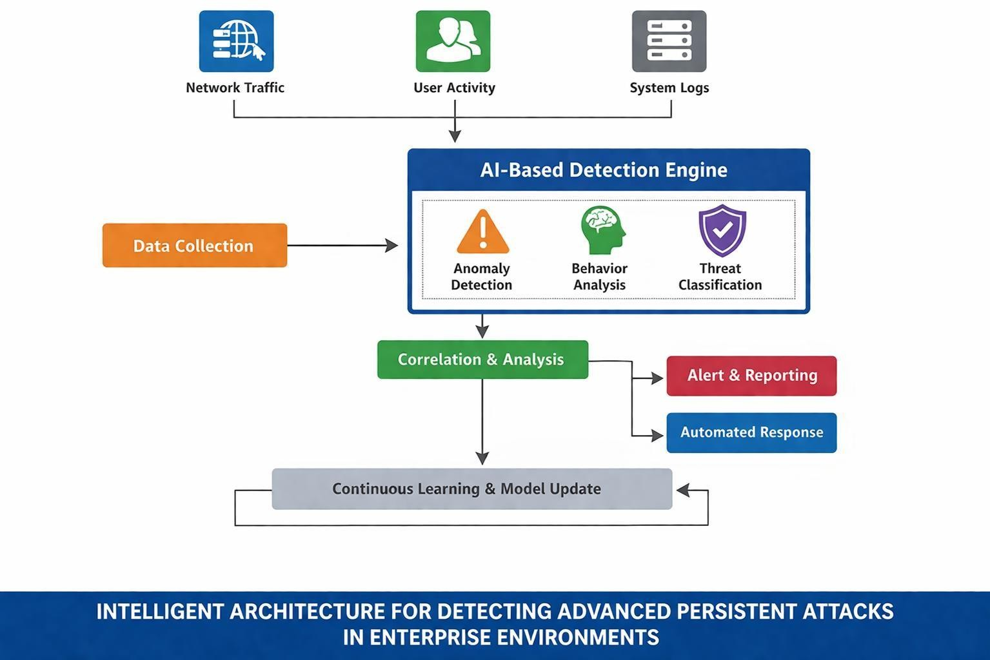

UML REPRESENTATION

UML stands for Unified Modeling Language. UML is a standardized general-purpose modeling language in the field of object-oriented software engineering. The standard is managed, and was created by, the Object Management Group.
The goal is for UML to become a common language for creating models of object oriented computer software. In its current form UML is comprised of two major components: a Meta-model and a notation. In the future, some form of method or process may also be added to; or associated with, UML.
The Unified Modeling Language is a standard language for specifying, Visualization, Constructing and documenting the artifacts of software system, as well as for business modeling and other non-software systems. The UML represents a collection of best engineering practices that have proven successful in the modeling of large and complex systems. The UML is a very important part of developing objects oriented software and the software development process. The UML uses mostly graphical notations to express the design of software projects.

- Provide users a ready-to-use, expressive visual modeling Language so that they can develop and exchange meaningful models.
- Provide extendibility and specialization mechanisms to extend the core concepts.
- Be independent of particular programming languages and development process.
- Provide a formal basis for understanding the modeling language.
- Encourage the growth of OO tools market.
- Support higher level development concepts such as collaborations, frameworks, patterns and components.
- Integrate best practices.

CLASS DIAGRAM
The class diagram is used to refine the use case diagram and define a detailed design of the system. The class diagram classifies the actors defined in the use case diagram into a set of interrelated classes. The relationship or association between the classes can be either an "is-a" or "has-a" relationship. Each class in the class diagram may be capable of providing certain functionalities. These functionalities provided by the class are termed "methods" of the class. Apart from this, each class may have certain "attributes" that uniquely.
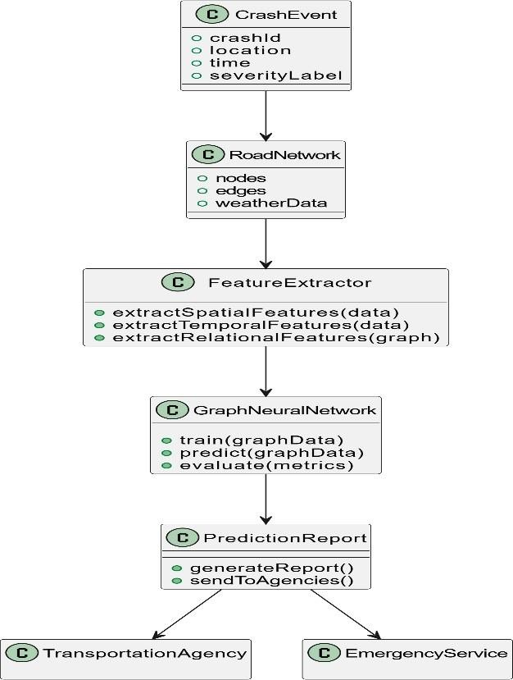
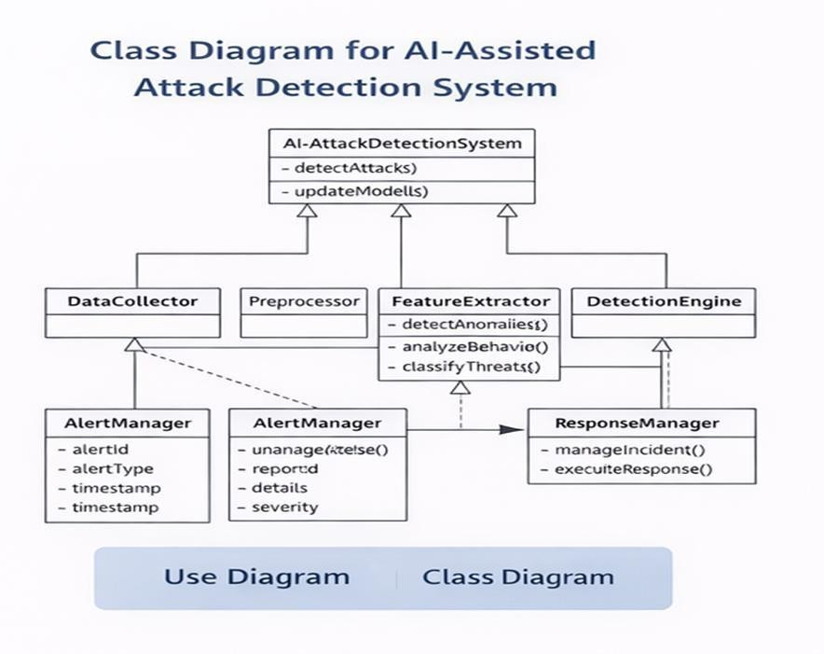

USECASE DIAGRAM

A use case diagram in the Unified Modeling Language (UML) is a type of behavioral diagram defined by and created from a Use-case analysis. Its purpose is to present a graphical overview of the functionality provided by a system in terms of actors, their goals (represented as use cases), and any dependencies between those use cases. The main purpose of a use case diagram is to show what system functions are performed for which actor. Roles of the actors in the system can be depicted.
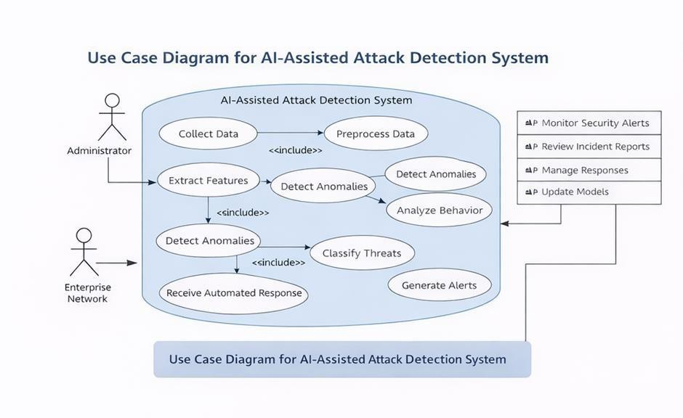

SEQUENCE DIAGRAM

A sequence diagram represents the interaction between different objects in the system. The important aspect of a sequence diagram is that it is time-ordered. This means that the exact sequence of the interactions between the objects is represented step by step. Different objects in the sequence diagram interact with each other by passing "messages".

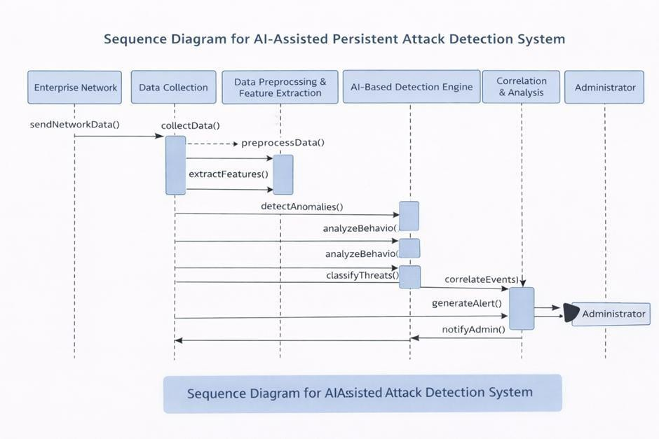

    - ACTIVITY DIAGRAM
Activity diagrams are graphical representations of workflows of stepwise activities and actions with support for choice, iteration and concurrency. In the Unified Modeling Language, activity diagrams can be used to describe the business and operational step-by- step workflows of components in a system. An activity diagram shows the overall flow of control.
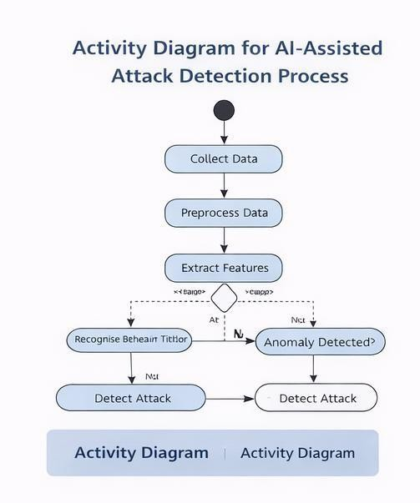

INPUT AND OUTPUT DESIGN INPUT DESIGN
The input design defines how data is collected and fed into the system.

Input Sources
    - Network traffic data (packets, flow records)
    - System logs (OS logs, application logs)
    - Firewall and IDS logs
    - User activity data (login, access patterns)

Input Format
    - Structured and semi-structured data (CSV, JSON, log files)
    - Real-time streaming data from network monitoring tools

Input Process
    - Data collection from multiple sources
    - Data cleaning and preprocessing (removal of noise, missing values)
    - Data transformation (normalization, encoding)
    - Feature extraction and selection

Input Characteristics
- Large-scale and high-dimensional data
- Continuous and real-time data flow
- Mixed data types (numerical + categorical)

OBJECTIVES
    - To design an AI-assisted end-to-end architecture for detecting persistent cyber-attacks.
    - To identify Advanced Persistent Threats (APTs) at early stages.
    - To enable real-time monitoring and detection of network activities.
    - To reduce false positives and false negatives in intrusion detection.
    - To detect both known and unknown (zero-day) attacks.
    - To integrate multiple data sources such as network traffic, system logs, and user behavior.
    - To automate threat detection and response mechanisms.
    - To develop a scalable and efficient system for enterprise environments.
    - To implement machine learning and deep learning algorithms for intelligent analysis.
    - To provide continuous learning and adaptation to evolving cyber threats.

OUTPUT DESIGN

The output design defines how results are presented to users or systems.

Output Types
- Threat detection alerts
- Classification results (normal or attack)
- Anomaly scores
- Attack type identification

Output Format
- Dashboard visualization (graphs, charts)
- Alert notifications (email/system alerts)
- Reports (logs, summaries)

Output Features
- Real-time alerts for suspicious activities
- Detailed reports with attack insights
- Visual representation of network behavior
- Risk level indication (low, medium, high)

Output Actions
- Automated response (block IP, isolate system)
- Alert generation for administrators
- Logging of detected incidents for future analysis

SYSTEM IMPLEMENTATION

SOURCE CODE
from django.shortcuts import render # Create your views here.
from django.shortcuts import render

# Create your views here. import pandas as pd import joblib
import os
from sklearn.preprocessing import StandardScaler, LabelEncoder from sklearn.ensemble import RandomForestClassifier
from sklearn.model_selection import train_test_split, GridSearchCV, cross_val_score
from sklearn.metrics import accuracy_score,classification_report,confusion_matrix,ConfusionMatrixDispla y
from imblearn.over_sampling import SMOTE import matplotlib.pyplot as plt
from django.conf import settings
from sklearn.feature_selection import RFE import pandas as pd
from sklearn.model_selection import train_test_split from sklearn.preprocessing import LabelEncoder
from sklearn.feature_extraction.text import TfidfVectorizer from sklearn.pipeline import Pipeline
from sklearn.naive_bayes import MultinomialNB from sklearn.metrics import classification_report import joblib
import os
from sklearn.ensemble import RandomForestClassifier from sklearn.linear_model import LogisticRegression

BASE_DIR = os.path.dirname(os.path.dirname(os.path.abspath( file ))) # Load and preprocess data

from django.shortcuts import render import pandas as pd
import numpy as np import joblib

import os
import matplotlib.pyplot as plt from django.conf import settings

from sklearn.preprocessing import LabelEncoder, StandardScaler from sklearn.model_selection import train_test_split
from sklearn.metrics import accuracy_score

from sklearn.ensemble import RandomForestClassifier, AdaBoostClassifier from sklearn.linear_model import LogisticRegression
from sklearn.neighbors import KNeighborsClassifier from sklearn.tree import DecisionTreeClassifier from sklearn import svm
from sklearn.neural_network import MLPClassifier from xgboost import XGBClassifier

# ========================================================= # TRAINING VIEW
# =========================================================
def training(request):

dataset_path = os.path.join(settings.MEDIA_ROOT, 'Darpa.csv') dataset = pd.read_csv(dataset_path)

#
# ENCODE STRING FEATURE COLUMNS #
feature_encoders = {}

for col in dataset.columns:
if dataset[col].dtype == 'object' and col != "attack_cat": le = LabelEncoder()
dataset[col] = le.fit_transform(dataset[col].astype(str)) feature_encoders[col] = le

#
# ENCODE TARGET COLUMN #
attack_encoder = LabelEncoder()
dataset['attack_cat'] = attack_encoder.fit_transform(dataset['attack_cat']) dataset.fillna(dataset.mean(), inplace=True)
#
# SPLIT FEATURES & TARGET #

y = dataset['attack_cat']
X = dataset.drop(columns=['attack_cat']) feature_names = X.columns.tolist()
#
# SCALING #
scaler = StandardScaler() X_scaled = scaler.fit_transform(X)

#
# TRAIN TEST SPLIT #
X_train, X_test, y_train, y_test = train_test_split( X_scaled, y, test_size=0.2, random_state=42 )
results = {} #
# TRAIN FUNCTION #
def train_model(name, model):
model.fit(X_train, y_train)

pred = model.predict(X_test)
acc = accuracy_score(y_test, pred) results[name] = acc
joblib.dump({
"model": model, "features": feature_names, "scaler": scaler,
"feature_encoders": feature_encoders, "attack_encoder": attack_encoder
}, os.path.join(settings.MEDIA_ROOT, f'{name}_model.pkl'))

#
# TRAIN MODELS #
train_model("RandomForest", RandomForestClassifier()) train_model("AdaBoost", AdaBoostClassifier()) train_model("LogisticRegression", LogisticRegression(max_iter=500)) train_model("KNN", KNeighborsClassifier())
train_model("SVM", svm.SVC())

train_model("DecisionTree", DecisionTreeClassifier()) train_model("MLP", MLPClassifier(max_iter=500)) train_model("XGBoost", XGBClassifier())

#
# PLOT GRAPH #
plt.figure(figsize=(10,5)) plt.bar(results.keys(), results.values()) plt.xticks(rotation=45) plt.ylabel("Accuracy")
plt.title("Cyber Attack Detection Model Comparison")

graph_path = os.path.join(settings.MEDIA_ROOT, 'accuracy_graph.png') plt.tight_layout()
plt.savefig(graph_path) plt.close()
results_df = pd.DataFrame(list(results.items()), columns=['Algorithm','Accuracy']) return render(request, 'users/accuracy.html', {
'results': results_df.to_html(index=False),
'graph_url': '/media/accuracy_graph.png'
})

# ========================================================= # PREDICTION VIEW
# =========================================================
def prediction(request):

context = {}
model_path = os.path.join(settings.MEDIA_ROOT, "RandomForest_model.pkl") if not os.path.exists(model_path):
context["error"] = "Model not trained yet. Please run training first." return render(request, "users/prediction.html", context)
model_data = joblib.load(model_path) model = model_data["model"]
train_features = model_data["features"] scaler = model_data["scaler"]
feature_encoders = model_data.get("feature_encoders", {}) attack_encoder = model_data.get("attack_encoder")

if request.method == "POST":

try:

csv_file = request.FILES["csv_file"] df = pd.read_csv(csv_file)

#
# ENCODE FEATURE COLUMNS #
for col, le in feature_encoders.items():
if col in df.columns:
df[col] = df[col].astype(str) df[col] = df[col].apply(
lambda x: le.transform([x])[0] if x in le.classes_ else 0
)
#
# ALIGN COLUMNS #
for col in train_features:
if col not in df.columns: df[col] = 0
df = df[train_features] #
# SCALE #
df_scaled = scaler.transform(df)

#
# PREDICT #
predictions = model.predict(df_scaled)

# CONVERT NUMERIC TO ATTACK NAME
if attack_encoder is not None:
predictions = attack_encoder.inverse_transform(predictions) df["Predicted_Attack"] = predictions
context["table"] = df.to_html(classes="table table-bordered table-striped")

except Exception as e:
context["error"] = f"Prediction failed: {str(e)}"

return render(request, "users/prediction.html", context) import os
def ViewDataset(request):
dataset = os.path.join(settings.MEDIA_ROOT, 'Darpa.csv') import pandas as pd
df = pd.read_csv(dataset, nrows=100) df = df.to_html(index=None)
return render(request, 'users/viewData.html', {'data': df})

from django.shortcuts import render, redirect from .models import UserRegistrationModel from django.contrib import messages

def UserRegisterActions(request): if request.method == 'POST':
user = UserRegistrationModel( name=request.POST['name'], loginid=request.POST['loginid'], password=request.POST['password'], mobile=request.POST['mobile'], email=request.POST['email'], locality=request.POST['locality'], address=request.POST['address'], city=request.POST['city'], state=request.POST['state'], status='waiting'
)
user.save()
messages.success(request,"Registration successful!") return render(request, 'UserRegistrations.html')

def UserLoginCheck(request):
If request.method == "POST":
loginid = request.POST.get('loginid') pswd = request.POST.get('pswd')
print("Login ID = ", loginid, ' Password = ', pswd) try:
check = UserRegistrationModel.objects.get(loginid=loginid, password=pswd) status = check.status
print('Status is = ', status) if status == "activated":
request.session['id'] = check.id request.session['loggeduser'] = check.name request.session['loginid'] = loginid

request.session['email'] = check.email data = {'loginid': loginid} print("User id At", check.id, status)
return render(request, 'users/UserHomePage.html', {}) else:
messages.success(request, 'Your Account Not at activated') return render(request, 'UserLogin.html')
except Exception as e: print('Exception is ', str(e)) pass
messages.success(request, 'Invalid Login id and password') return render(request, 'UserLogin.html', {})

def UserHome(request):
return render(request, 'users/UserHomePage.html', {})

def index(request):
return render(request,"index.html")

ALGORITHM USED

Random Forest(RF)

  - Description: Random Forest (RF) is an ensemble learning algorithm that combines multiple decision trees to improve classification performance. Each tree in the forest is trained on a random subset of the data and makes predictions independently. The final prediction is based on the majority vote from all the trees in the forest, making the algorithm robust against overfitting.
  - Application: Random Forest is used in this project to classify network activities as normal or malicious. It helps in detecting Advanced Persistent Threats (APTs) by analyzing patterns in network traffic and user behavior.

Advantages:

    - High accuracy for classification tasks.
    - Handles missing data well.
    - Effective with high-dimensional data.

- Ada Boost (Adaptive Boosting)

- Description: AdaBoost is a boosting technique that combines several weak classifiers in sequence to build a strong one. Each new model focuses on correcting the mistakes of the previous one until all data is correctly classified or a set number of iterations is reached.
- Application: In this project, AdaBoost is used to enhance the performance of the threat detection system by combining multiple weak classifiers. It focuses on difficult-to-classify network activities, improving the detection of hidden and advanced cyber threats. AdaBoost helps in increasing overall accuracy while reducing classification errors. It is effective in analyzing network traffic and user behavior for identifying malicious patterns..

Advantages:

  - Reduces bias and improves overall model reliability.
  - Focuses on misclassified data to enhance learning performance.
  - Effective for detecting complex and hard-to-classify patterns.

Logistic Regression

- Description: This Logistic Regression is a supervised machine learning algorithm used for classification problems. Unlike linear regression, which predicts continuous values it predicts the probability that an input belongs to a specific class.
- Application: Logistic Regression is used in this project to classify network activities as normal or malicious based on probability. It helps in detecting potential cyber threats by analyzing patterns in network traffic and user behavior. The model provides simple and efficient classification with interpretable results. It is useful for handling binary classification tasks in real-time threat detection.

Advantages:
  - Logistic Regression performs well when the dataset is linearly separable.
  - It makes no assumptions about distributions of classes in feature space.
  - It can interpret model coefficients as indicators of feature importance.

K-Nearest Neighbors(KNN)

- Description: K-Nearest Neighbor (KNN) is a simple and widely used machine learning technique for classification and regression tasks. It works by identifying the K closest data points to a given input and making predictions based on the majority class or average value of those neighbors.

- Application: K-Nearest Neighbors (KNN) is used in this project to classify network activities based on similarity with nearby data points. It helps in detecting anomalies by comparing current network behavior with previously observed patterns. The algorithm is effective in identifying suspicious activities and potential cyber threats. It is simple and useful for pattern-based classification in cyber security systems.

Advantages:
  - No need to train as it just stores the data and uses it during prediction.
  - Only needs to set the number of neighbors (k) and a distance method.
  - Works for both classification and regression problems.

Super Vector Machine(SVM)

- Description: Support Vector Machine (SVM) is a supervised machine learning algorithm used for classification and regression tasks. It tries to find the best boundary known as hyperplane that separates different classes in the data. It is useful when you want to do binary classification like spam vs. not spam or cat vs. dog.
- Application: Support Vector Machine (SVM) is used in this project to classify network activities by finding the optimal boundary between normal and malicious data. It is effective in handling high- dimensional data such as network traffic and system logs. SVM helps in detecting complex cyber threats by identifying patterns and separating different classes accurately. It improves the reliability of threat detection in enterprise networks.

Advantages:
  - Support vector machine is very effective even with high dimensional data.
  - When classes in the data are points are well separated SVM works really well.
  - SVM can be used for both regression and classification problem.

Decision Tree Classifier

- Description: A Decision Tree helps us to make decisions by mapping out different choices and their possible outcomes. It‘s used in machine learning for tasks like classification and prediction. In this article, we‘ll see more about Decision Trees, their types and other core concepts.
- Application: Decision Tree Classifier is used in this project to classify network activities into normal or malicious based on decision rules. It analyzes features from network traffic, system logs, and user behavior to detect cyber threats. The model is easy to understand and helps in identifying important factors influencing attacks. It supports efficient and quick decision-making in threat

detection.

Advantages:
  - When using Decision tree algorithm it is not necessary to normalize the data.
  - The data pre-processing step for decision trees requires less time.
  - The data pre-processing step for decision trees requires less code and analysis.

SOFTWARE ENVIRONMENT

    - PYTHON
Python is a high-level, interpreted, and object-oriented programming language widely used for developing applications in domains such as web development, data science, artificial intelligence, and machine learning. It is known for its simple syntax, readability, and vast ecosystem of libraries.
Python is Interpreted − Python executes code line by line using an interpreter, eliminating the need for
compilation and making debugging easier.
      - Python is Interactive − It allows interaction with the interpreter, enabling quick testing and rapid
development of code.
      - Python is Object-Oriented − Python supports object-oriented programming concepts such as classes and objects, which help in building modular, reusable, and scalable applications.
      - Python is Beginner-Friendly − It is easy to learn and supports the development of both simple scripts
and complex applications.
      - Python also provides extensive libraries such as NumPy, Pandas, and Scikit-learn for data analysis and machine learning.
In this project, Python is used for implementing machine learning models, data preprocessing, feature extraction, and integrating Explainable AI techniques such as SHAP and LIME for better model interpretability.

DJANGO
Django is a high-level Python web framework used for developing secure, scalable, and robust web applications. It follows the Model-View-Template (MVT) architecture, which helps in separating business logic, user interface, and data handling.
Django provides built-in features such as URL routing, request handling, authentication, session management, and database integration, which reduces development time and effort.

Web Application Development:
Django is used to build the web interface of the intrusion detection system, enabling users to interact with the application through forms, dashboards, and visualization panels.

Integration with Machine Learning:
Django integrates machine learning models into the backend, allowing real-time prediction and classification of network traffic data.

Database Integration:
Django supports databases like SQLite and MySQL to store user details, system logs, prediction results, and historical data.

User Authentication:
Django provides secure login and registration features, ensuring that only authorized users can access the system.
Additionally, Django enhances security by protecting against common attacks such as SQL injection and cross-site scripting (XSS).
In this project, Django is used to develop the complete web-based platform for data input, prediction, visualization, and explanation of results using SHAP and LIME.

PYCHARM
PyCharm is a powerful Integrated Development Environment (IDE) specifically designed for Python development. It is developed by JetBrains and provides advanced tools for coding, debugging, testing, and project management.
PyCharm supports multiple operating systems including Windows, macOS, and Linux, and offers both Community and Professional editions.

Features of PyCharm:
      - Code completion, syntax highlighting, and real-time error detection
      - Integrated debugging tools for testing and fixing code
      - Support for web frameworks like Django
      - Built-in version control integration (Git, GitHub)
      - Easy navigation between files, classes, and functions
      - Virtual environment support for dependency management
In this project, PyCharm is used for developing and testing machine learning models, writing backend logic, and managing the Django application efficiently.

VISUAL STUDIO CODE (VS CODE)
Visual Studio Code (VS Code) is a lightweight and flexible source code editor developed by Microsoft. It supports multiple programming languages and provides a wide range of extensions for web development, Python programming, and machine learning.
VS Code is highly customizable and suitable for both beginners and professionals.

Features of VS Code:
      - Intelligent code completion and syntax highlighting
      - Integrated terminal for running commands and scripts
      - Debugging support for identifying and fixing errors
      - Extension support for Python, Django, and data science tools
      - Version control integration with Git
      - Fast performance with minimal system resource usage
In this project, VS Code is used for developing the frontend (HTML, CSS), integrating backend services, and managing the overall workflow of the application.

JUPYTER NOTEBOOK
Jupyter Notebook is an open-source, web-based interactive computing platform widely used in data science and machine learning. It allows developers to write and execute code in a cell-based structure, making experimentation and analysis easier.
It is particularly useful for testing machine learning models and visualizing data.

Features of Jupyter Notebook:
      - Interactive code execution in cells
      - Easy visualization of data using graphs and charts
      - Supports libraries such as NumPy, Pandas, Matplotlib, and Scikit-learn
      - Combines code, output, and explanations in a single document
      - Useful for debugging and step-by-step analysis
In this project, Jupyter Notebook is used for data preprocessing, training machine learning models, analyzing results, and visualizing patterns in network data.

MACHINE LEARNING LIBRARIES
Machine learning libraries play a crucial role in building intelligent models for detecting cyber threats.

      - Scikit-learn: Used for implementing machine learning algorithms such as Random Forest, SVM,KNN, and Logistic Regression.
      - TensorFlow/Keras: Used for building deep learning models like neural networks.
      - Pandas: Used for data manipulation and analysis.
      - NumPy: Used for numerical computations and handling large datasets.
      - Matplotlib/Seaborn: Used for data visualization and graphical representation.
In this project, these libraries are used to process large volumes of network data, train models, evaluate performance, and visualize results effectively.

TESTING

The purpose of testing is to discover errors. Testing is the process of trying to discover every conceivable fault or weakness in a work product. It provides a way to check the functionality of components, sub assemblies, assemblies and/or a finished product It is the process of exercising software with the intent of ensuring that the Software system meets its requirements and user expectations and does not fail in an unacceptable manner. There are various types of test. Each test type addresses a specific testing requirement.

TYPES OF TESTS

Unit testing
Unit testing involves the design of test cases that validate that the internal program logic is
functioning properly, and that program inputs produce valid outputs. All decision branches and internal code flow should be validated. It is the testing of individual software units of the application .it is done after the completion of an individual unit before integration. This is a structural testing, that relies on knowledge of its construction and is invasive. Unit tests perform basic tests at component level and test a specific business process, application, and/or system configuration. Unit tests ensure that each unique path of a business process performs accurately to the documented specifications and contains clearly defined inputs and expected results.

Integration testing
Integration tests are designed to test integrated software components to determine if they actually run as one program. Testing is event driven and is more concerned with the basic outcome of screens or fields. Integration tests demonstrate that although the components were individually satisfaction, as shown by successfully unit testing, the combination of components is correct and consistent. Integration testing is specifically aimed at exposing the problems that arise from the combination of components.

Functional test
Functional tests provide systematic demonstrations that functions tested are available as specified by the business and technical requirements, system documentation, and user manuals. Functional testing is centered on the following items:

Valid Input : identified classes of valid input must be accepted. Invalid Input : identified classes of invalid input must be rejected. Functions : identified functions must be exercised.
Output : identified classes of application outputs must be exercised Systems/Procedures : interfacing systems or procedures must be invoked.
Organization and preparation of functional tests is focused on requirements, key functions, or special test cases. In addition, systematic coverage pertaining to identify Business process flows; data fields, predefined processes, and successive processes must be considered for testing. Before functional testing is complete, additional tests are identified and the effective value of current tests is determined.

System Test
System testing ensures that the entire integrated software system meets requirements. It tests a configuration to ensure known and predictable results. An example of system testing is the configuration oriented system integration test. System testing is based on process descriptions and flows, emphasizing pre- driven process links and integration points.

White Box Testing
White Box Testing is a testing in which in which the software tester has knowledge of the inner workings, structure and language of the software, or at least its purpose. It is purpose. It is used to test areas that cannot be reached from a black box level.

Black Box Testing
Black Box Testing is testing the software without any knowledge of the inner workings, structure or language of the module being tested. Black box tests, as most other kinds of tests, must be written from a definitive source document, such as specification or requirements document, such as specification or requirements document. It is a testing in which the software under test is treated, as a black box .you cannot
see into it. The test provides inputs and responds to outputs without considering how the software works.

Unit Testing
Unit testing is usually conducted as part of a combined code and unit test phase of the software lifecycle, although it is not uncommon for coding and unit testing to be conducted as two distinct phases.

Test strategy and approach
Field testing will be performed manually and functional tests will be written in detail.

Test objectives
- All field entries must work properly.
- Pages must be activated from the identified link.
- The entry screen, messages and responses must not be delayed.

Features to be tested
- Verify that the entries are of the correct format
- No duplicate entries should be allowed
- All links should take the user to the correct page.
- ​

Integration Testing
Software integration testing is the incremental integration testing of two or more integrated software components on a single platform to produce failures caused by interface defects.
The task of the integration test is to check that components or software applications, e.g. components in a software system or – one step up – software applications at the company level – interact without error.
Test Results: All the test cases mentioned above passed successfully. No defects encountered.

Acceptance Testing
User Acceptance Testing is a critical phase of any project and requires significant participation by the end user. It also ensures that the system meets the functional requirements.
Test Results: All the test cases mentioned above passed successfully. No defects encountered.
Test cases1:
Test case for Login form:

FUNCTION: | LOGIN
EXPECTED RESULTS: | Should Validate the user and check his
 | existence in database
ACTUAL RESULTS: | Validate the user and checking the user against  the database
LOW PRIORITY | No
HIGH PRIORITY | Yes

Test case2:
Test case for User Registration form:

FUNCTION: | USER REGISTRATION
EXPECTED RESULTS: | Should check if all the fields are filled by the  user and saving the user to database.
ACTUAL RESULTS: | Checking whether all the fields are field by user  or not through validations and saving user.
LOW PRIORITY | No
HIGH PRIORITY | Yes

Test case3:
Test case for Change Password:
When the old password does not match with the new password ,then this results in displaying an error message as ― OLD PASSWORDDOES NOT MATCH WITH THE NEW PASSWORD‖.
FUNCTION: | Change Password
EXPECTED RESULTS: | Should check if old password and new password  fields are filled by the user and saving the user to database.
ACTUAL RESULTS: | Checking whether all the fields are field by user  or not through validations and saving user.
LOW PRIORITY | No
HIGH PRIORITY | Yes

Functional Testing
Functional testing ensures that each function of the system works according to the specified requirements.

Data Input Validation
This test verifies whether the system correctly accepts and processes network traffic data and user activity logs.

Attack Detection Verification
The system is tested to confirm that machine learning models correctly identify suspicious activities and

cyber attack patterns.

Prediction Result Generation
This test checks whether the AI models generate accurate predictions based on the analyzed network data.

Alert Notification Functionality
The testing ensures that the alert system properly sends notifications to security administrators when a threat is detected.

Non-Functional Testing
Non-functional testing evaluates the performance, reliability, and efficiency of the system.

Performance Testing
This test measures how quickly the system processes large volumes of network data and generates predictions.

Security Testing
Security testing ensures that the system is protected against unauthorized access, data breaches, and other vulnerabilities.

Load Testing
Load testing evaluates how the system performs when handling high levels of network traffic and multiple user requests.

Reliability Testing
Reliability testing checks whether the system can operate continuously for long periods without crashes or performance degradation.

Implementation:

Below are the code and output screens
To run project double click on runWebServer.bat‘ file to start python server and then will get below page

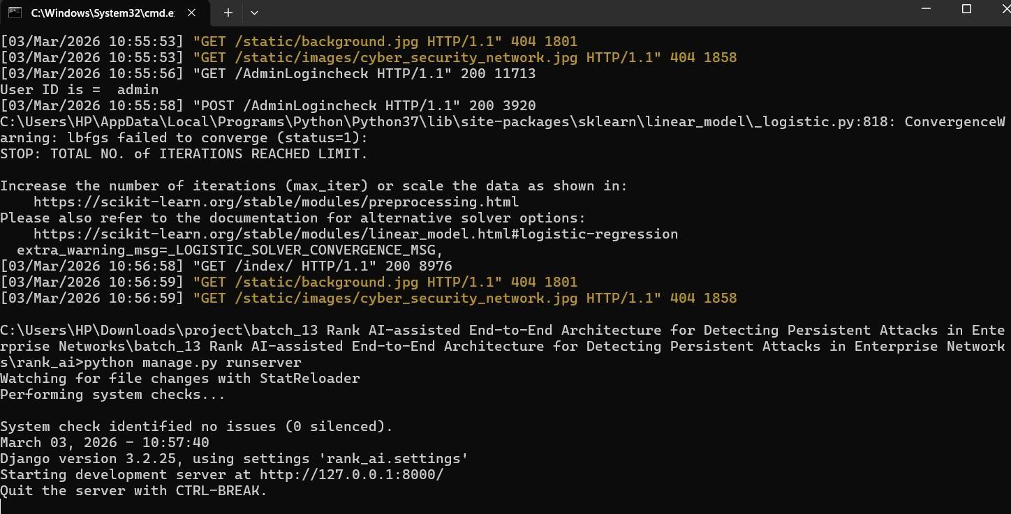

In above screen python server started and now open browser and enter URL as http://127.0.0.1:8000/index.html and then press enter key to get below page

Fig 6.3 Run web server

RESULTS
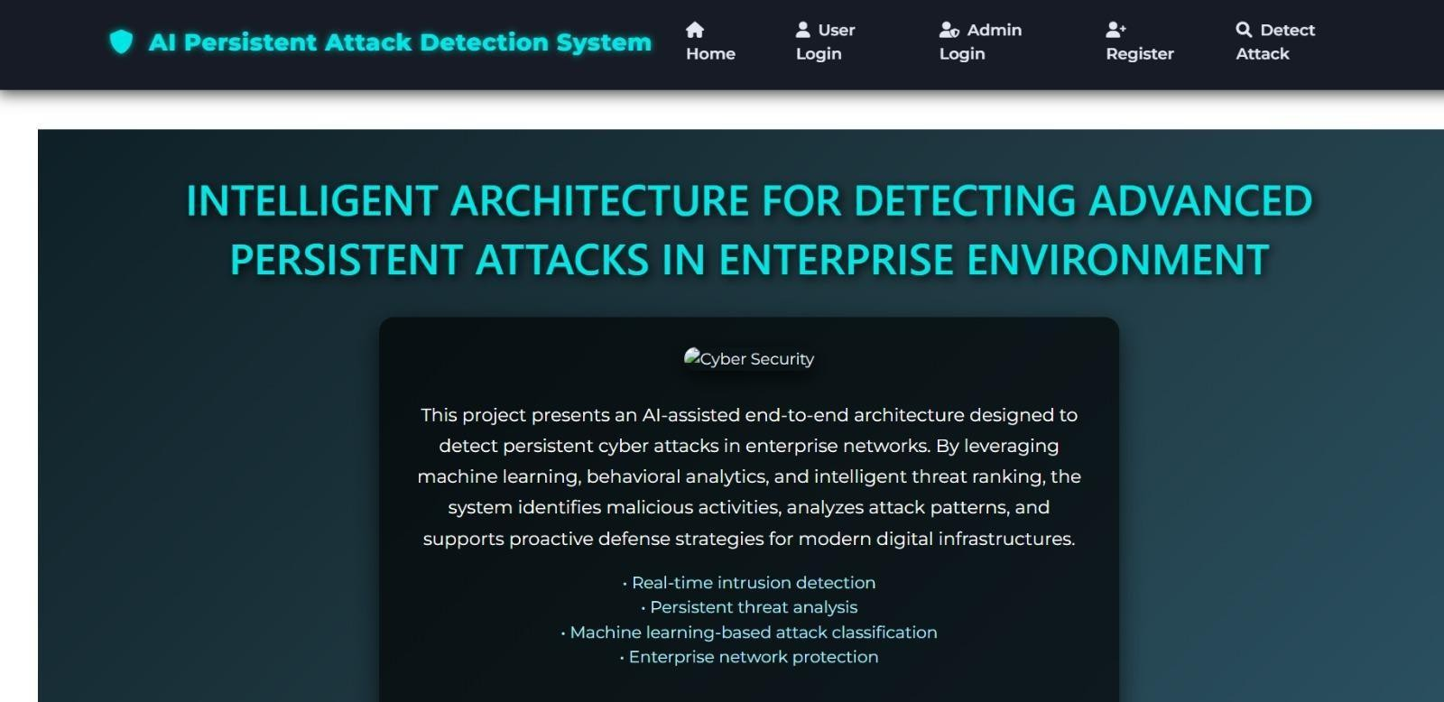
Fig 7.1 “Home page”

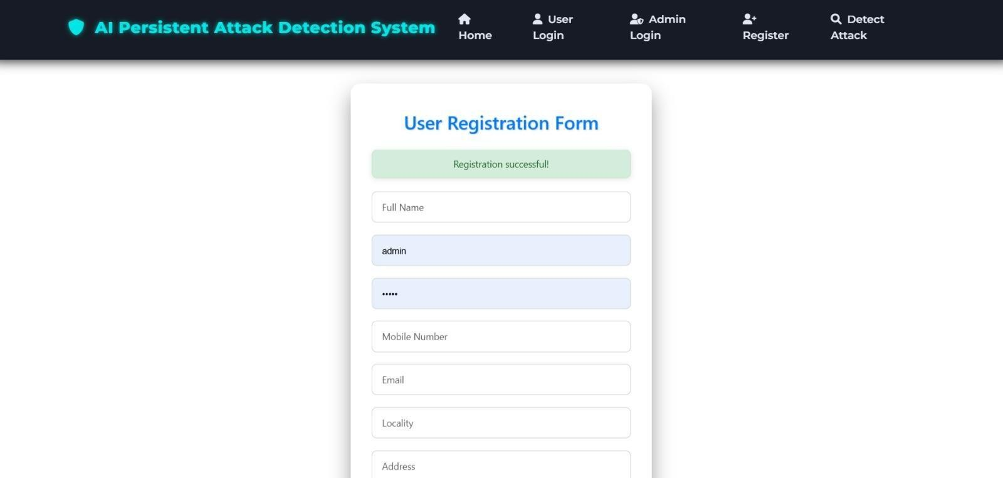

Fig 7.2 “ Registration page”

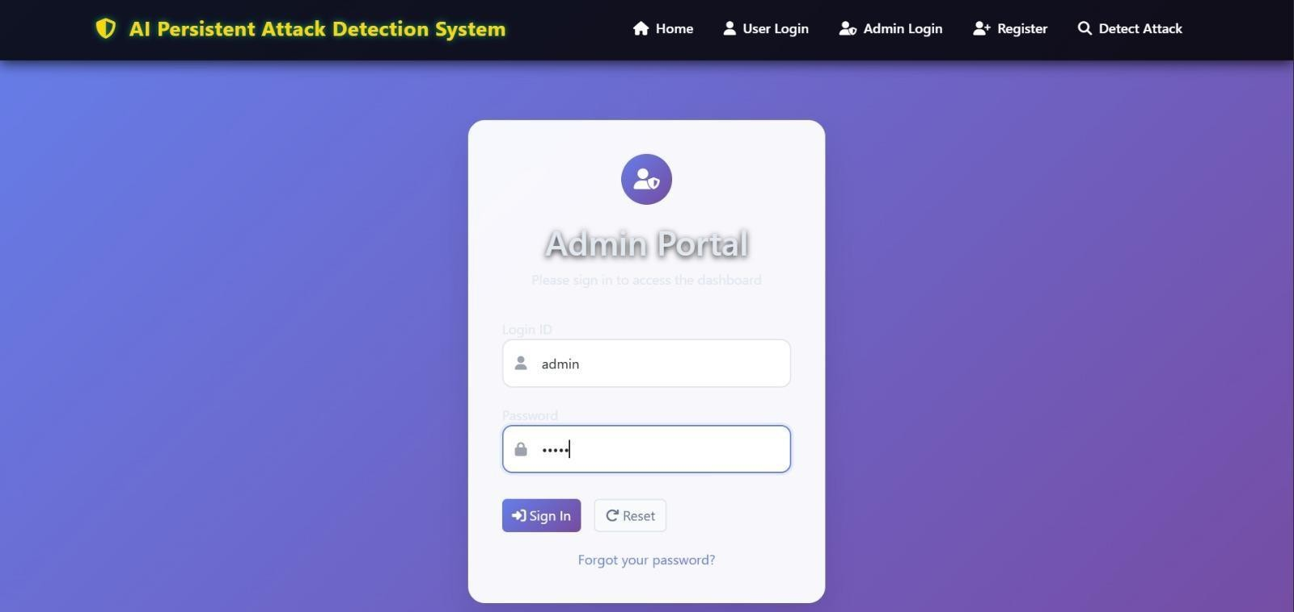
Fig 7.3 “ Admin login page”

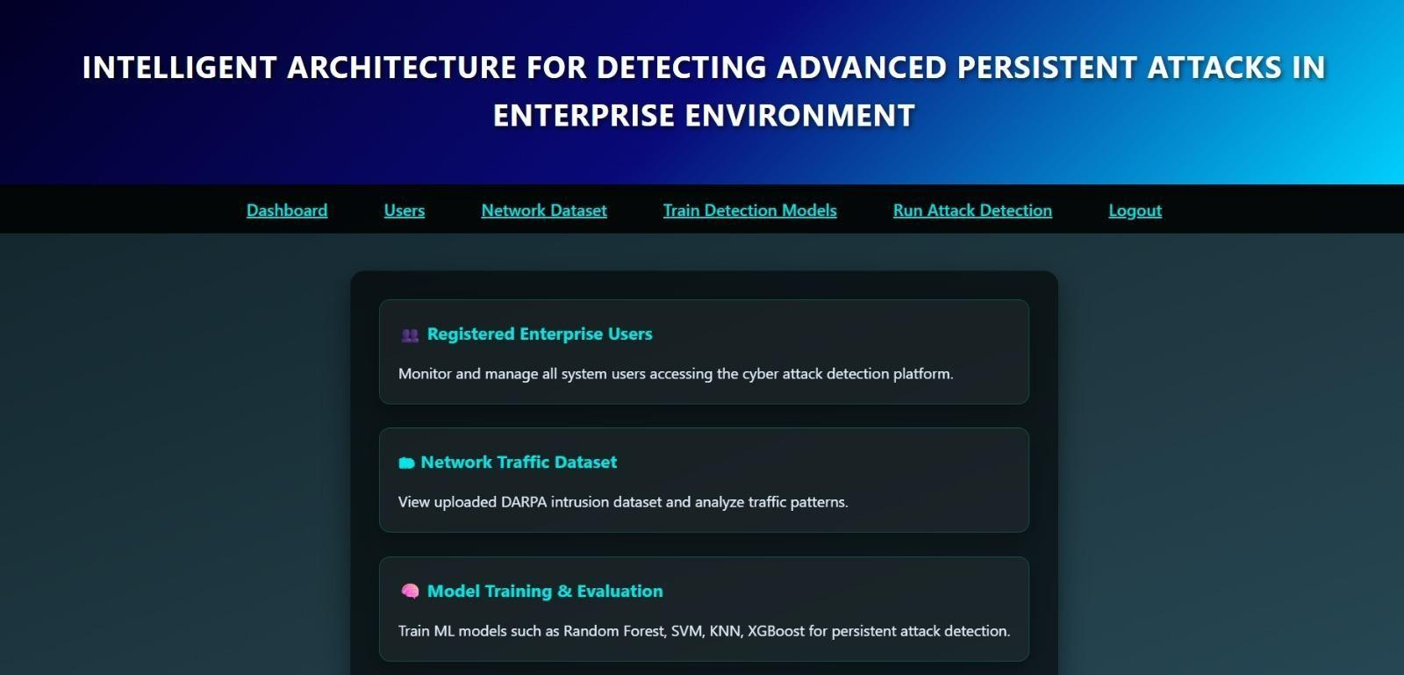

Fig 7.4 Module 1: “Home page after the admin login”

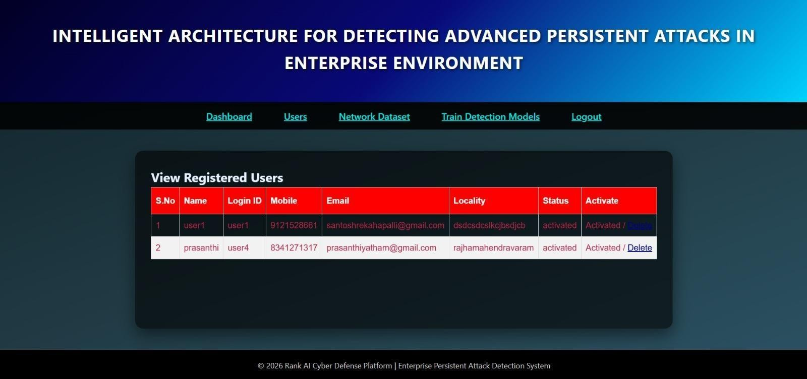

Fig 7.5 Module 2: “View Registered Users”

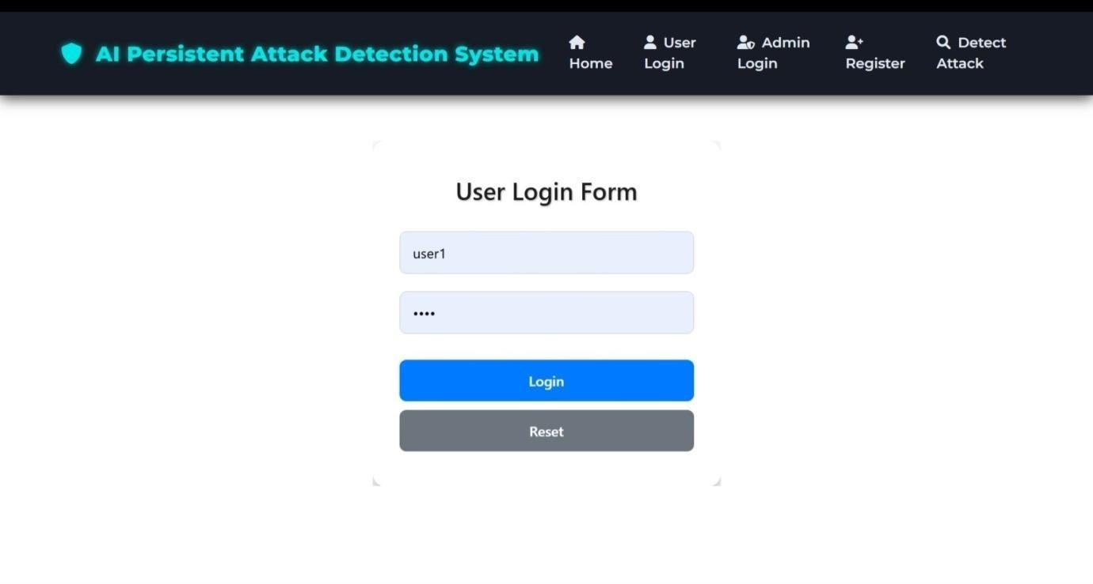

Fig 7.6 “ User-login page”

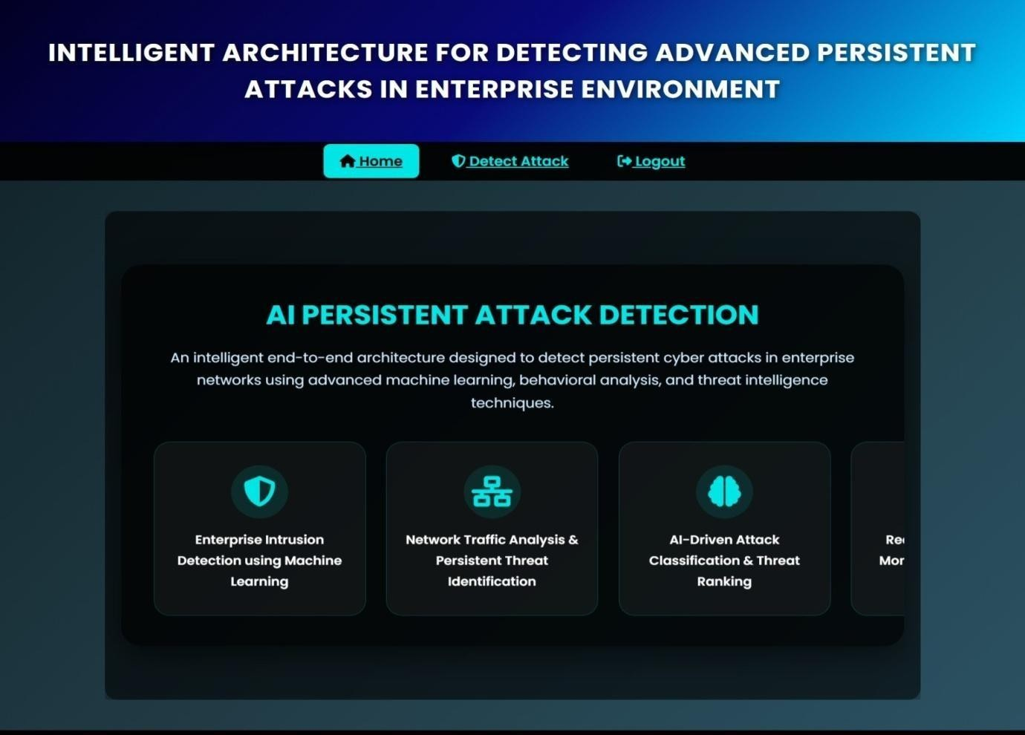
Fig 7.7 “Home page after the User-login page”
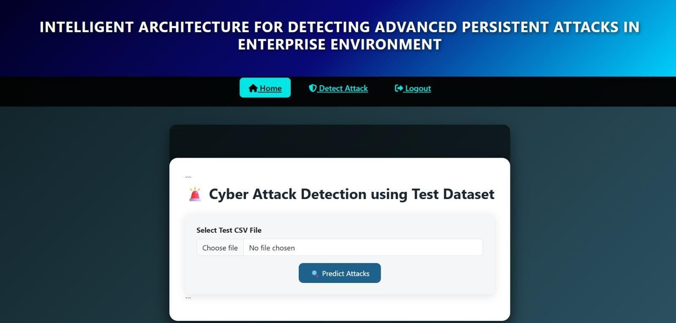

Fig 7.8 “Cyber Attack detection Using Test Dataset”

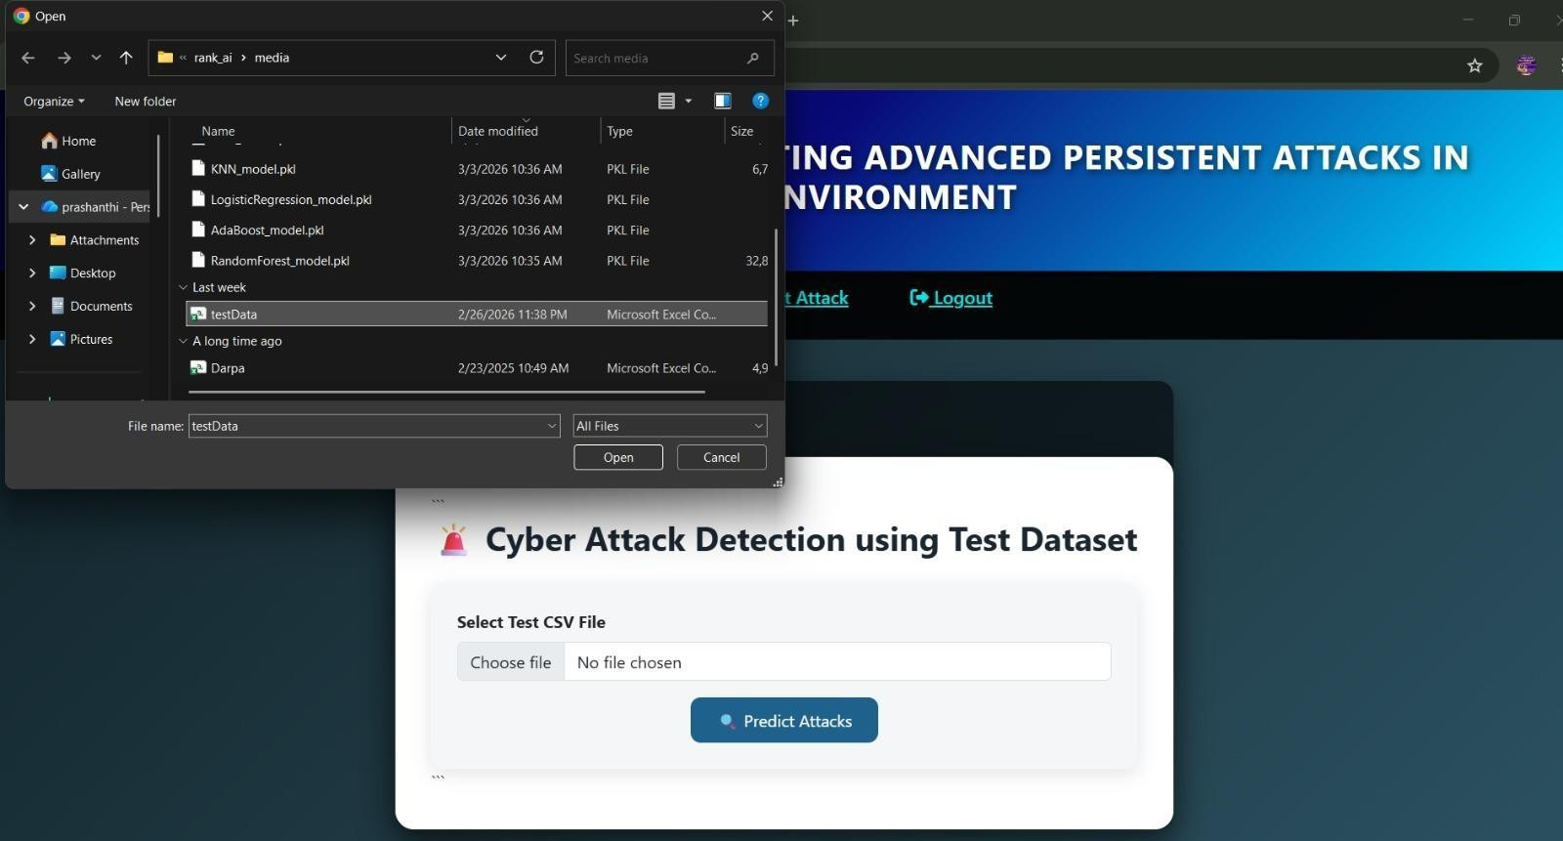

Fig 7.9 “Dataset Upload”
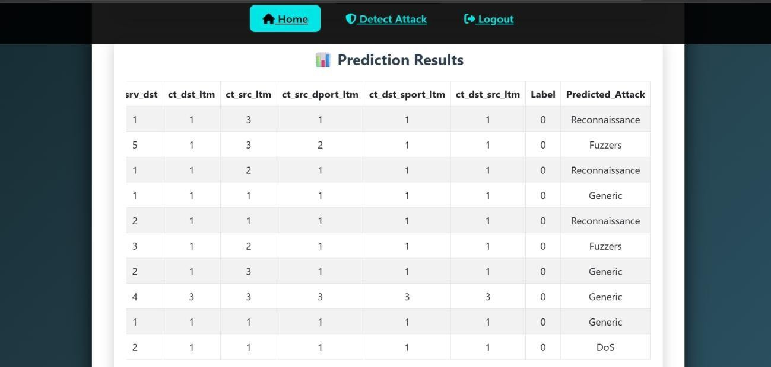

Fig 7.10 Module3: “Cyber Attack Detected”

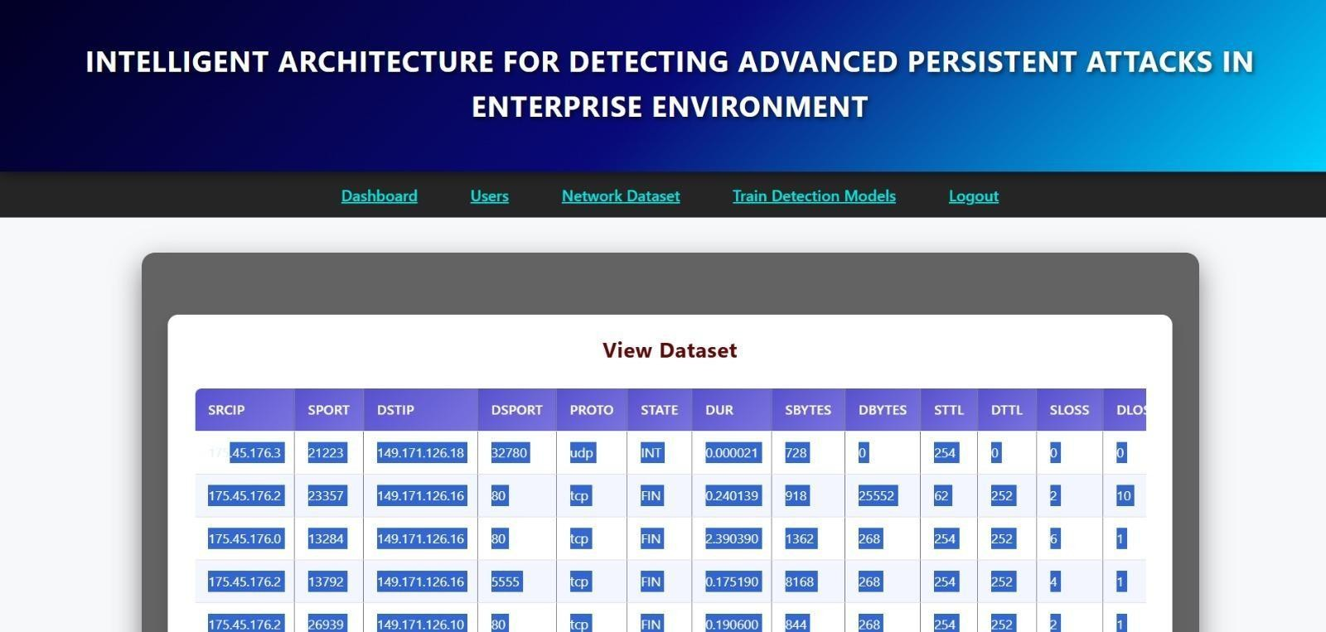

Fig 7.11 Module 4: “View Dataset”

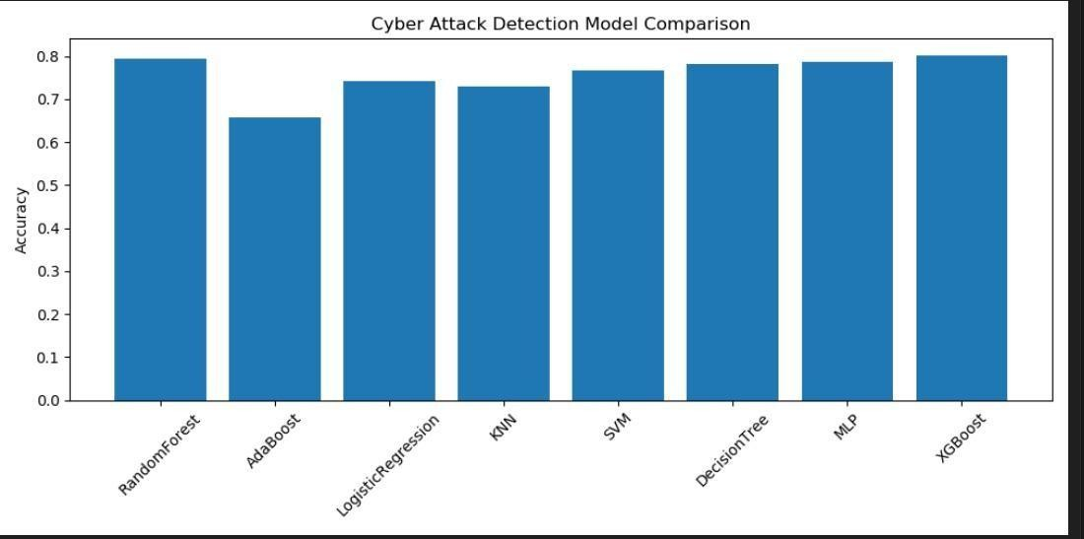

Fig 7.12 Module 5: “Model Comparision”

CONCLUSION AND FUTUREWORK
The proposed AI-assisted end-to-end architecture for detecting persistent attacks in enterprise networks provides an effective and intelligent solution to modern cyber security challenges. By integrating machine learning and deep learning techniques with comprehensive data collection, preprocessing, and analysis, the system is capable of identifying both known and unknown threats with high accuracy. Unlike traditional security mechanisms, the proposed approach offers real-time detection, reduced false positives, and the ability to analyze multi-stage attack patterns. The implementation using multiple classification algorithms further enhances reliability by comparing and selecting the best-performing model for attack detection. Additionally, the system‘s continuous learning capability ensures adaptability to evolving cyber threats. Overall, this work demonstrates a scalable, automated, and efficient framework that significantly improves enterprise network security and helps organizations proactively defend against sophisticated and persistent cyber-attacks.

SCOPE: The proposed AI-assisted system for detecting persistent attacks in enterprise networks can be further enhanced in several ways to address emerging cybersecurity challenges and improve overall performance. In the future, the system can be extended by incorporating advanced deep learning models such as hybrid neural networks and transformer-based architectures to achieve even higher accuracy in detecting complex and evolving attack patterns. Integration with real-time big data processing frameworks like Apache Spark or Hadoop can enable faster analysis of large-scale network traffic in distributed environments. The system can also be improved by incorporating real-time threat intelligence feeds and integrating with Security Information and Event Management (SIEM) tools to provide a more comprehensive security ecosystem. Additionally, the use of explainable AI (XAI) techniques can help security analysts better understand the decision-making process of models, increasing transparency and trust. Deployment of the system in cloud and edge computing environments can further enhance scalability and reduce latency in detection.
Moreover, incorporating automated incident response and self-healing mechanisms can make the system more proactive in mitigating threats without human intervention. Future work can also focus on enhancing data privacy and security throusgh techniques such as federated learning and encryption-based processing. Overall, continuous advancements in AI and cybersecurity technologies will enable the system to evolve into a more robust, adaptive, and intelligent solution for protecting enterprise networks against sophisticated and persistent attacks.

REFERENCES

- M. Tavallaee, E. Bagheri, W. Lu, and A. A. Ghorbani, ―A Detailed Analysis of the KDD CUP 99 Data Set,‖ Proceedings of the IEEE Symposium on Computational Intelligence for Security and Defense Applications, 2009.
- N. Moustafa and J. Slay, ―UNSW-NB15: A Comprehensive Data Set for Network Intrusion Detection
Systems,‖ Military Communications and Information Systems Conference (MilCIS), 2015.

- I. Goodfellow, Y. Bengio, and A. Courville, Deep Learning, MIT Press, 2016.

- T. M. Mitchell, Machine Learning, McGraw-Hill, 1997.

- S. J. Stolfo, W. Fan, W. Lee, A. Prodromidis, and P. K. Chan, ―Cost-Based Modeling for Fraud and Intrusion Detection: Results from the JAM Project,‖ Proceedings DARPA Information Survivability Conference and Exposition, 2000.
- W. Lee and S. J. Stolfo, ―A Framework for Constructing Features and Models for Intrusion Detection
Systems,‖ ACM Transactions on Information and System Security, vol. 3, no. 4, pp. 227–261, 2000.

- J. Kim, J. Kim, H. L. T. Thu, and H. Kim, ―Long Short-Term Memory Recurrent Neural Network Classifier for Intrusion Detection,‖ International Conference on Platform Technology and Service (PlatCon), 2016.
- A. L. Buczak and E. Guven, ―A Survey of Data Mining and Machine Learning Methods for Cyber Security Intrusion Detection,‖ IEEE Communications Surveys & Tutorials, vol. 18, no. 2, pp. 1153– 1176, 2016.
- Y. Xin et al., ―Machine Learning and Deep Learning Methods for Cybersecurity,‖ IEEE Access, vol.
6, pp. 35365–35381, 2018.

- D. Berman, A. Buczak, J. S. Chavis, and C. L. Corbett, ―A Survey of Deep Learning Methods for
Cyber Security,‖ Information, vol. 10, no. 4, 2019.

